Prototype report

Food restaurant management

**Table contents**

1. Introduction 1

1.1 Purpose of the prototype report 1

1.2 Status of the prototype 1

2. Navigation Flow 2

3. Prototype 3

1. **Introduction**
   1. Purpose of the prototype report

This report provides a description and evaluation of the website prototype. It focuses on two categories: “Look like” and “Work like”. It shows overview of UI which is displayed in this website. In another face, this report also describes for reader the workflow or step by step understand the system that bases on events.

* 1. Status of the prototype

This is the first version of website prototype report, so it provide some basic views about website in two faces: Functional and display. With display, that is HTML script, it shows status picture about website. From that, users can amaze about website: What they have and How to use it. In contract, with functional, it helps readers know that how to access website with simple steps, and then, they can use system that only bases on simple actions.

This version also is backbone of the prototype report. It means that all of main things will be touch upon. And this prototype report will be fulfill in next versions that depends on requirement changing.

1. **Navigation flow**

This section should show presents the prototype navigation flow. All core capabilities screenshot should be included in this document and presented to client. The screenshots presented in this document should follow the same order as the navigation flow.

In the first version or early round of prototyping, if the navigation flow is not the critical point of your project, you can skip this section with rationale provided.

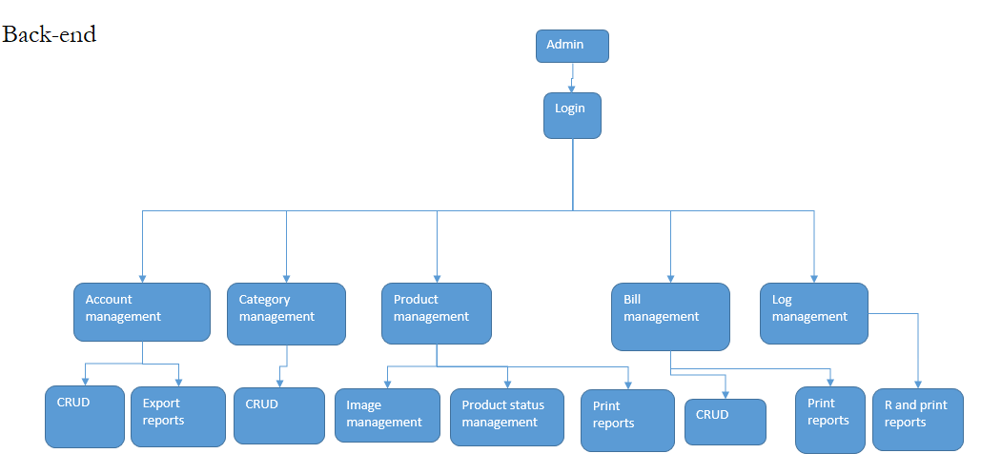

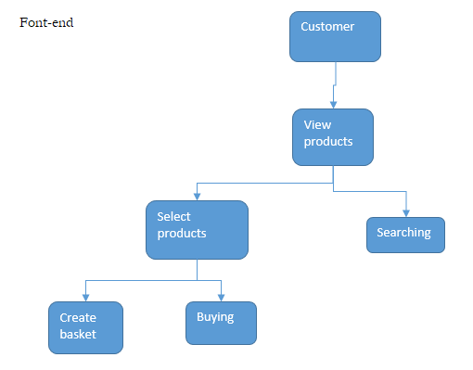

1. **Prototype**

Most students think about prototype as sample screenshots of system’s graphical user interface (GUI). It is not always true. With the risk-driven approach, you should select the riskiest module or the functionalities that you are uncertain about to develop a prototype. The prototype, especially the initial version, does not have to be in the form of GUI. It could be in the form of algorithm prototyping, interoperability prototyping, performance testing and etc. Again, if you select to prototype on GUI in order to model the story telling, or look and feel, it would be much better NOT to pick the easy one such as login page.

* 1. Login

|  |  |
| --- | --- |
| Description | << Briefly describe what this screenshot is about. >>  This screenshot shows GUI of login form. |
| Pre-condition | << Which screen shot leads to this screen shot? What condition will lead to this screenshot? >>  Access to admin page or object management page but without admin role. |
| Post condition | << What will happen in the system after processing this screenshot? What’s next? >>  Base on login status:   1. Go to admin management page if login successes 2. Still in login page. |

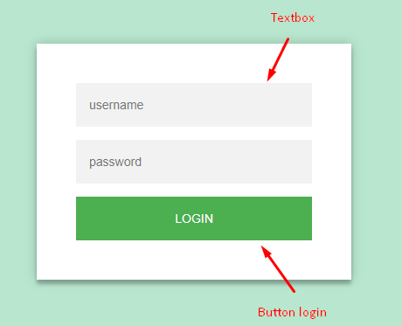

If login fails

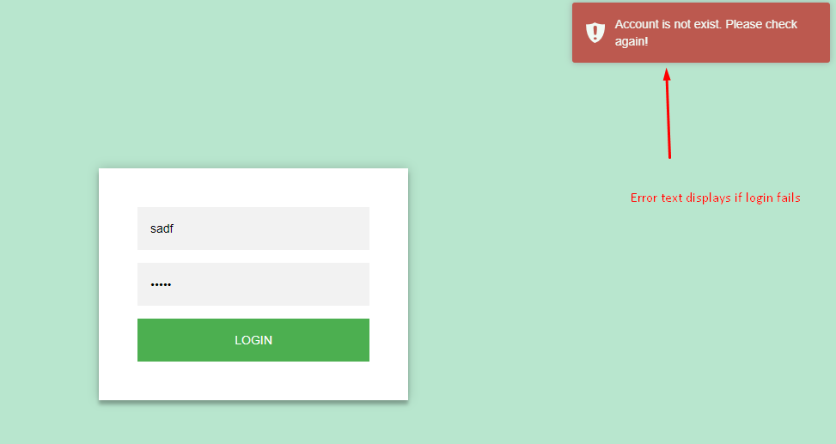

If login successes

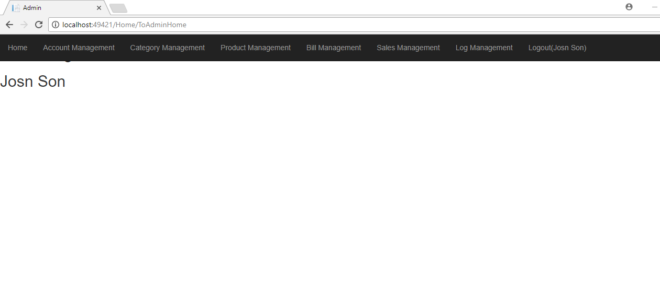

* 1. Account management

|  |  |
| --- | --- |
| Description | << Briefly describe what this screenshot is about. >>  This display list of account, form create new and detail of an account |
| Pre-condition | << Which screen shot leads to this screen shot? What condition will lead to this screenshot? >>  From admin page after login successful. User select link in menu to access page |
| Post condition | << What will happen in the system after processing this screenshot? What’s next? >>  User can interact with system: create, update and remove accounts. |

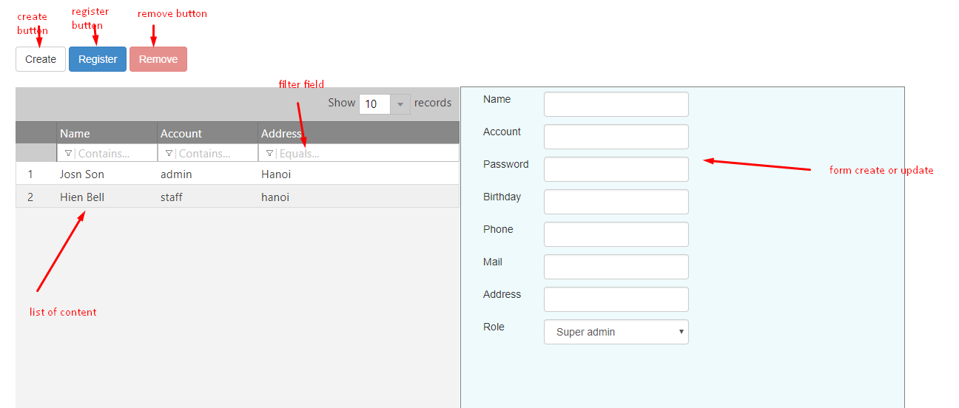

* 1. Category management

|  |  |
| --- | --- |
| Description | << Briefly describe what this screenshot is about. >>  This display list of category, form create new and detail of a category |
| Pre-condition | << Which screen shot leads to this screen shot? What condition will lead to this screenshot? >>  From admin page after login successful. User select link in menu to access page |
| Post condition | << What will happen in the system after processing this screenshot? What’s next? >>  User can interact with system: create, update and remove a category. |

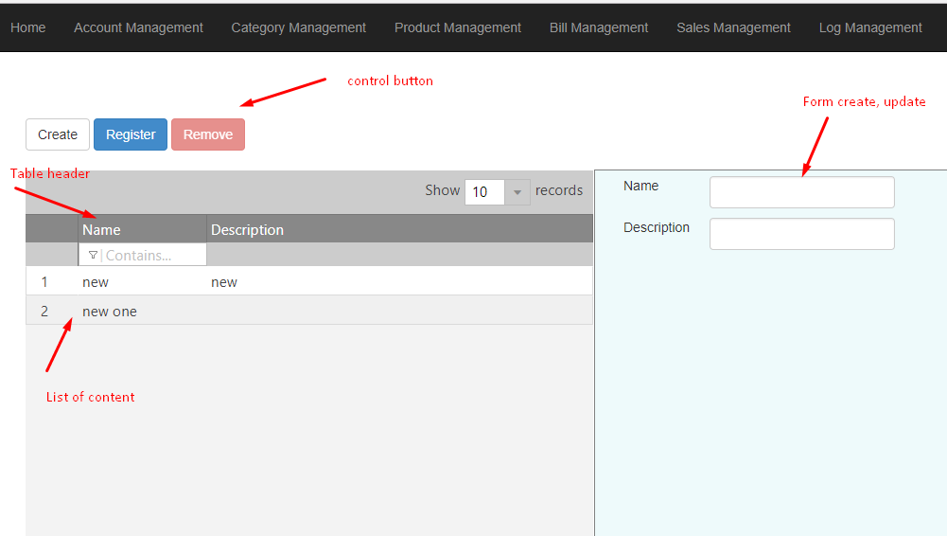

* 1. Log management

|  |  |
| --- | --- |
| Description | << Briefly describe what this screenshot is about. >>  This display list of log, button to download excel file |
| Pre-condition | << Which screen shot leads to this screen shot? What condition will lead to this screenshot? >>  From admin page after login successful. User select link in menu to access page |
| Post condition | << What will happen in the system after processing this screenshot? What’s next? >>  User can interact with system: view list of log and print. |

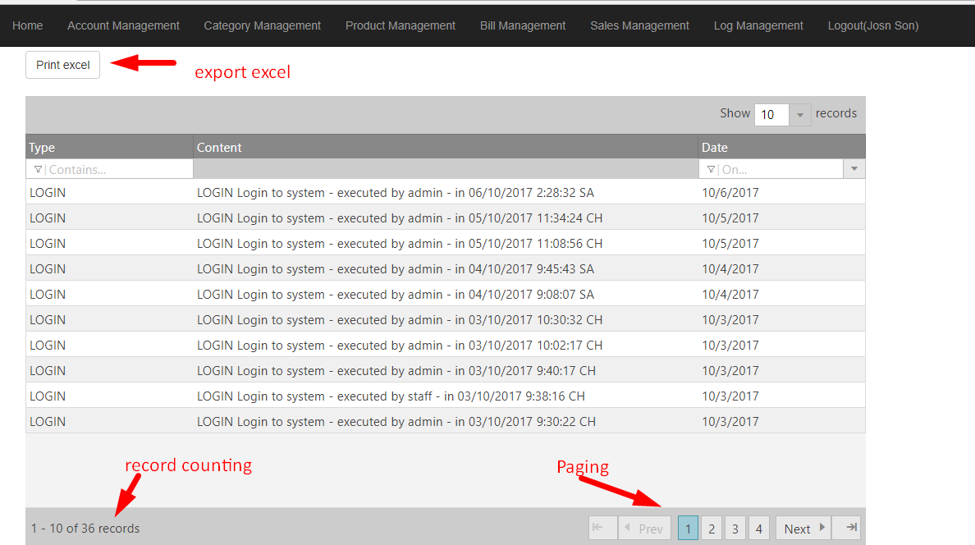

* 1. Logout

|  |  |
| --- | --- |
| Description | << Briefly describe what this screenshot is about. >>  Display confirm dialog when click logout |
| Pre-condition | << Which screen shot leads to this screen shot? What condition will lead to this screenshot? >>  From admin page after login successful. User select link in menu to access page |
| Post condition | << What will happen in the system after processing this screenshot? What’s next? >>  Base on confirm result:   1. Go to login page if click yes in confirm dialog 2. Close confirm dialog if click no in confirm dialog |

